POLLUTION INCIDENT RESPONSE

MANAGEMENT PLAN FOR SEWERAGE AND TREATMENT PLANT

NELLIGEN HOLIDAY PARK

REVISION DATE: 7/4/23

CONTACT DETAILS, COMMUNICATING WITH NEIGHBOURS AND THE LOCAL COMMUNITY, ACTIONS TO BE TAKEN DURING OR IMMEDIATELY AFTER AN EVENT.

STEPS NOTES/RISKS WHO

SEWERAGE SYSTEMS

Report may be received via: From staff or
Report of unlicenced sewage discharge
- After hours Duty Manager (4478 1076) or members of
- Manager, Reception Staff, Guests the public

Refer to On-Call Duty Roster and advise Grounds Mgr Park Staff/
1. Advise Grounds Mgr/ Owners immediately
And Owners - Person to person voice contact must be made Duty Mgr
(DO NOT LEAVE VOICE MESSAGES).

2. Note time of notification, name and contact details of notifying person, location and nature of discharge

Record information on Incident Report Form and in Diary Duty Manager

***High priority to be given to achieving minimum response time***

3. Attend site and assess situation
Assess Event – Where sewage overflows are of significant volume Duty Manager or
(ie >100L), or may remain uncontained, or have discharged to or Owners
adjacent to a body of water, the event is to be considered Significant.

4. Advise Grounds Manager/Duty Manager and Owners.
For Significant Events -

- In Hours – contact the Duty Manager, if unavailable,
contact the Area Manager who will request
Environmental Health Surveyor (EHS) attendance
(4474 1000).

- Out of Hours – contact the Duty Manager (0491 151 110) Duty Manager or
Duty Manager is to request attendance of the Owner Owners

Grounds Manager/Duty Manager to then contact the Owners on
mobile phone or after hours on home phone numbers as follows:

- Michelle Halemai (Area Mgr) 0472 599 267 or where unavailable
- Carlo Campana (Partner) 0414 821 832

Early Warning Mechanism
5. Early Warning Mechanism

Checks on Sewerage Treatment Works are carried out Duty Manager or
Daily/Weekly/Monthly and Quarterly (See Appendix A attached) Owners

6. If discharge has potential to affect waterways, oyster beds or public contact areas or if volume discharged is significant, notify external authorities.

- Notify external authorities immediately if discharge is affecting
- a waterway/oyster beds or has the potential to do so.

Contact:
- Eurobodalla Shire Council Environmental 4472 1000
- EPA Pollution Line 131 555
- EPA Queanbeyan Office 6229 7002
- Workcover NSW 131 050 Duty Manager or
- Fire & Rescue 000 Owners
- Batemans Bay Marine Park Authority 4476 0802

And where a waterway or shellfish beds are potentially
affected, contact:

- NSW Fisheries – Batemans Bay 4478 9100

And where the discharge has the potential to affect
public health, contact: -

- Dept. of Health 6289 1555 or
1800 020 103

7. Arrange Water Quality Samples if required
Liaise directly with external authorities and agree on
sampling program. Duty Manager or
Owners
8. Isolate public from contamination

Use safety fencing and erect signage if required Duty Manager or
Owners

Turn off any contributing upstream pump stations and
9. Contain discharge if possible
monitor wet well levels. Use straw bales or other Duty Manager or
sediment arresting materials to contain spill. Owners

10. Deploy staff & equipment to rectify problem
Call in mobile pumps/Gensets and Vacuum Trucks as
required: Duty Manager or
Owners

- SUEZ Australia 4474 4355

- Eurobodalla Coast Pumpouts 4474 3622
0428 743 622

11. Clear mains blockages if applicable

Deploy suitable traffic control if roadway affected.
Call in Tech Services electrical or mechanical technicians Duty Manager or
If any sewerage pumping station fault cannot be rectified. Owners

- Simmark Batemans Bay (02) 4413 1433

12. Retrieve solids on site

Place all solids or contaminated clean up materials in Duty Manager or
Containers or bags for disposal at landfill site. Owners
13. Disinfect site including gutters and downstream areas.

Disinfect site including gutters and downstream areas.
Where event declared significant, consult Duty Manager/Owner Environmental Health Surveyor for appropriate methods or EHS
of disinfection.
14. Determine extent of environmental impact/pollution

Check for extent of contamination travel in drains and
gutters. Check for discharge to waterways. Environmental Health
Surveyor

15. Final Inspection

Check all public health issues completely Environmental Health
Surveyor
16. Document Incident Report

Complete “EPA Incident Report” form. Duty Manager or
Owners
17. Draft the EPA Incident Report if required.

Forward the completed EPA Incident Report to EPA
Regional office. Duty Manager or
Owners

18. Tool-Box Meetings
Tool-Box Meetings are a method of staff training Duty Manager or
Owners

Notes:
- Sewerage Treatment Works Overflow Drills are
carried out every 12 months to keep managers and
staff up to date with procedures
- Sewerage Treatment Works Location Map and
Dangerous Goods Location Map are attached and form
part of this PIRMP (See Appendix B and Appendix C)
- Fire Procedures (Appendix D), Bomb Threat Procedures
(Appendix E) and Flood Procedures (Appendix F) are also
attached and form part of this PIRMP.
- Early Warning Mechanisms are in place by way of Daily/Weekly
Monthly/Quarterly/Yearly procedures (see attached).

APPENDIX A:

TREATMENT PLANT TESTING PROCEDURE

DAILY

- Read flow meter and record in “Sewerage Log” folder

- Inspect effluent colour and odour

- Check chlorine and alum tanks, record in “Sewerage Log” folder in changes

- Sign “Sewerage Log” folder as checker

PEAK SEASON - 60-minute aeration and 60-minute settling
NON-PEAK - 5-minute mix / 5–10-minute aeration

WEEKLY

- Collect the ladder and test equipment

- Wait until agitation cycle has been going for 10-15 minutes before starting sludge test.

- Take sample (from 1st tank 60cm below water level) in steel cylinder, empty into the Perspex cylinder up to the 1000ml mark, let it stand for 30 minutes and then record the sludge level (should be around the 600ml mark), record level. Record every hour for 5 hours.

- Take ph reading from the 1st tank and record, (ph should be between 6.5 and 7.5) if ph falls below, add lime.

- Record main tank and discharge readings

- Record colour and odour levels

- Check chlorine, read from 2nd tank should be between .20 and .50
and check chlorine drum, exchange if needed.

- Clean filter on 2nd tank, test float and check water clarity

- Check level of sludge tank and record

- Take sample of decant water (from tap near pump) & test chlorine levels,
should be between .20 & .50. Record in folder.

MONTHLY

- Check all floats and clean

- Take sample of sludge (from sludge tank)

- Check alum containers and refill

- Check chlorine containers and refill

QUARTERLY

External preventative maintenance and routine checks. Inspection from Waste Water Maintenance Pty Ltd in accordance with the scope of works.

6 MONTHLY

Remove 2 x aerator blowers – inspect, test and clean

YEARLY

Replace Bi-O filter every 2nd year

APPENDIX B:

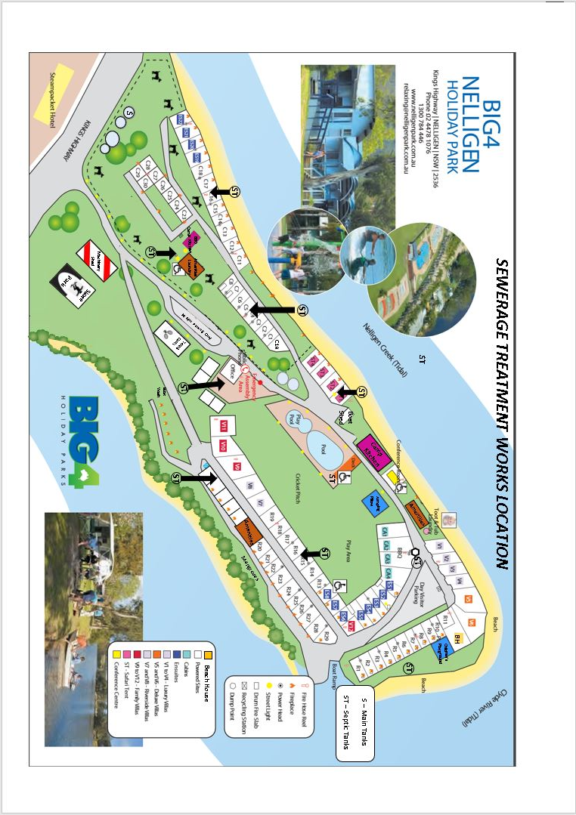

APPENDIX C:

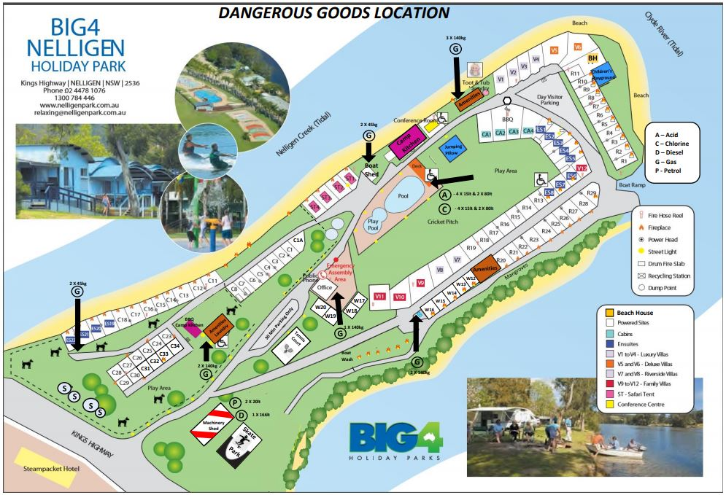

APPENDIX D:

FIRE & SAFETY PROCEDURES

- Bomb Threat Procedures:
- Record exact wording of threat
- Keep caller talking – try to obtain as much information as possible
- DO NOT HANG UP
- Report your call to the Manager and the Police
- Record details of the caller’s voice and background noise
- Await instructions from authorised persons

- In the Event of Fire:
- Raise the alarm, contact the Fire Brigade (000)
- Alert other occupants
- Notify Park Managers
- Evacuate the immediate area
- Assemble as instructed by management
- When instructed - EVACUATE

- Evacuation Procedures:
When an alert is given, all employees must be aware of the following procedures:
- All occupants to assemble AT THE OFFICE
- Office staff is to print an in-house guest report by category and site to enable all guests to be accounted for
- When instructed to evacuate leave your accommodation
- Move quickly and calmly to the assembly area and remain in the company of park staff or designated leaders

APPENDIX E:

BOMB THREAT CHECK LIST

Questions to ask:

- When is the bomb going to explode?
- Where did you put the bomb?
- When did you put it there?
- What does the bomb look like?
- What kind of bomb is it?
- What will make the bomb explode?
- Did you place the bomb?
- Why did you place the bomb?
- What is your name?
- Where are YOU?
- Where are YOU?
- What is your address?

EXACT WORDING OF THREAT

______________________________________________________________________________________________________________________________________________________________________________________________________________________________________________________________________________________________________________________________________________________________________________________________________________________________
- Report immediately to the Managers
- Notify the Fire Brigade and Police
- Keep a list of any further calls or guest enquiries

FIRST AID BOXES

It is important to know the whereabouts of a first aid box (in reception), which is equipped to handle any minor accident, and the names of the first aid trained staff within the office whom you should contact for any serious or urgent medical treatment. When using the first aid boxes please advise your Manager if the stocks are getting low.

PLEASE BE AWARE THAT ALL BUILDINGS AND VILLAS HAVE BEEN DECLARED SMOKE FREE ZONES

Accident and Incident Reports

Any incident or accident should be reported immediately to a Manager. However, in the event that the Manager cannot action the incident immediately you should record the following:

- Time and date of incident
- Name, address and phone numbers of person involved
- How the incident occurred
- Where it occurred
- Were there any witnesses
- Was there any medical assistance needed
- Nature of the injury

Accident forms are available at reception. Failure to do this may jeopardise a subsequent claim for Workcare Compensation

ADVICE TO GUESTS IN THE EVENT OF BUSHFIRES THREATENING THE PARK

- DO NOT attempt to leave the park by car as the road may be cut by bushfires and you will hamper the efforts of the local fire brigade and emergency services personnel in gaining access to the park

- Close all windows and doors. If asked to evacuate, PLEASE DO NOT
Lock the villa/cabin doors as staff will do an occupancy check of all sites and lock doors behind them

- Take with you only necessities if asked to evacuate your villa/cabin or campsite. DON’T FORGET ANY MEDICATION YOU MAY BE TAKING

- Follow instructions and directions of staff at all times

- The ASSEMBLY POINT for evacuation is BESIDE THE RECEPTION OFFICE at this point staff will be accounting for all guests from our in-house guest reports. DO NOT WANDER OFF ON YOUR OWN

- Ensure that you keep your family members together

- Emergency Services Personnel may require us to move to another assembly point, so please WAIT FOR INSTRUCTIONS

MANAGERS PROCEDURES IN CASE OF EMERGENCY

- “CODE RED” “CODE RED” “CODE RED” is the emergency call given over the 2way radio, along with the location, to all staff alerting them of an emergency and telling them to proceed immediately to the given location and follow Duty Managers’ instructions

- Designate staff to immediately go to the area indicated to ascertain the situation

- Advise reception of false alarm or confirmed fire

IF THE FIRE IS CONFIRMED, IMPLEMENT EVACUATION:
- Advise reception of the area to be evacuated
- Appoint persons to notify other staff and guests about the evacuation
- Advise guests to close all windows. Do not lock the front doors as staff will do a check of all villas/cabins and will lock them up

- Check and lock all amenities and guest laundry
- Collect emergency keys for Fire Brigade
- Collect in-house guest lists
- Liaise with Fire Brigade for evacuation
- Proceed to the assembly area
- At assembly area, check with other staff on the status of guests and other staff. Report any missing persons to the Fire Brigade

IF FIRE BRIGADE MAKES NON-EVACUATION DECISION:

- Contact reception to inform other staff of situation

- Contact all guests who have enquired and reassure them

EVACUATION LIST

TIME:_________________ DATE:__________________

NATURE OF EMERGENCY (please circle)

FIRE

GAS EMISSION

BOMB THREAT

OTHER – GIVE DETAILS
________________________________________________________________________________________________________________________________________________________________________________________________________________

EMERGENCY SERVICES NOTIFIED (please circle)
FIRE BRIGADE 000 Eurobodalla Fire Control 4474-2855
POLICE 000 Batemans Bay Police 4472-0099
AMBULANCE 000

STEPS TO FOLLOW IF YOU DISCOVER A FIRE

- HELP RESCUE ANY PERSON IN IMMEDIATE DANGER, but only if it is safe to do so

- CLOSE THE DOOR ON THE FIRE, this helps to stop the fire spreading

- RAISE THE ALARM by contacting reception and advise the location of the fire

- ATTACK THE FIRE only if it is safe to do so, i.e. Only if it is safe to do so

- LEAVE THE AREA and report to reception

IF EVACUATING:

- WAIT FOR INSTRUCTIONS from the Manager
- MAKE SURE THAT ALL PEOPLE ARE EVACUATING calmly and in a timely manner and taking special care with elderly and disabled guests

- REPORT TO THE ASSEMBLY AREA
- DO NOT LEAVE the assembly area without permission from the Manager

GENERAL FIRE INFORMATION

It may not occur but what if you are in a holiday park which was constructed to meet fire standards, and which offers reasonable protection against such a calamity.

The chances of being involved in a fire may be a thousand to one.

But your chances of survival are much better if you understand in advance what to do in the case of a fire.

A lot of people are needlessly harmed because they did not know what to do.

The purpose of this book is to increase your chances, and those of our guests, of safety in the case of a fire.

In an emergency, the Park Manager will have final and absolute authority for the park including employees and guests.

A decision as to whether the immediate area or the entire park is to be evacuated is the responsibility of the Manager, pending the arrival of the Fire Brigade.

TYPES OF FIRES:

Class A

Refers to a fire in wood, paper and other such materials. These fires can be extinguished by the cooling and quenching action of water from fire hoses and water based extinguishers. Such extinguishers are only in RED coloured canisters.

Class B

Involves flammable and electrical fires. These can only be put out by CO2 Carbon Dioxide, BCF and Dry Chemical extinguishers.

FIRE PROTECTION & SAFETY:

Fire Extinguishers

Should it be necessary to use an extinguisher, ensure it is the correct one for the type of fire, and take time to read the instructions on the extinguisher in your work area.

How to work an extinguisher

The ability to use fire extinguishers must be part of ongoing fire prevention training. It is vital you are able to operate all extinguishers:

- Remove the locking pin
- Stand approximately two (2) metres away and point the nozzle at the base of the fire
- Depress the trigger
- Direct the spray at the base or seat of the fire in an arc sweeping motion

NEVER ATTEMPT TO EXTINGUISH AN ELECTRICAL OR FLAMMABLE LIQUID FIRE WITH FIRE.

NEVER ATTEMPT TO EXTINGUISH A GAS FIRE IF THE FLOW OF GAS CANNOT BE STEMMED.

IMPORTANT: ALL STAFF TO MAKE THEMSELVES FAMILIAR WITH THE LOCATION OF FIRE EQUIPMENT.

WHAT IF……..

A Smoke Detector or Alarm Goes Off?

Do not assume someone else has made the notification, check the immediate areas for signs of smoke and fire.

Remember to be alert. Do not ignore and indications of fire. The prevention and detection of fires is everyone’s responsibility.

There is Smoke?

Where there is smoke, there is not necessarily a fire. Smoke rises to the ceiling first. Smoke will contain poisonous gases and is very irritating to the eyes and makes it hard to breathe…..

So…..

- Smoke rises, so fresher cleaner air is along the floor. If necessary, crawl.
- DO NOT RUN, walk swiftly, DO NOT PANIC and DO NOT SHOUT FIRE.
- Stay calm…don’t hurry, keep relaxed and think your danger is almost always less that you imagine it to be.
- Do not enter a closed door if the door handle is warm
- You know the park better than the guest; you must assist in a calmer manner whenever possible.

THE LIFE YOU SAVE MAY BE YOUR OWN!!!

DO YOU SMELL SMOKE???

OCCUPATIONAL HEALTH AND SAFETY POLICY

It is the policy of Big4 Nelligen Holiday Park to conduct its activities in such a way as to provide an environment which, so far as practicable, protects the health, safety and welfare of all people at the workplace and actively encourages safe working practices.

Health and Safety is both an individual and shared responsibility of all Employers and Employees, Subcontractors, Advisors, Consultants and all work-related persons.

In order to support this policy Big4 Nelligen Holiday Park will:
- Comply with all relevant legislation and compliance standards and make adequate provision of resources to meet these requirements
- Promote health and safety awareness and the development of healthy and safe working procedures
- Provide information and, where necessary, training, instruction and adequate protective equipment
- Consult with employees on health and safety matters and on ways to reduce workplace hazards
- Maintain effective accident analysis and hazard reporting systems
- Regularly review health and safety performance

Employees, volunteers and visitors, for their part, will be expected to:

- Comply with all relevant legislation and compliance standards
- Wear appropriate protective clothing and equipment
- Report and, where appropriate, rectify hazards
- Accept responsibility for protecting themselves and others

No task will be undertaken if it is likely to compromise the health and safety of employees, volunteers and visitors. Appropriate consideration must be given to determining a safe and healthy work method for each and every activity.

RISK MANAGEMENT

The owners are committed to implementing risk management procedures for the business to ensure a safe working environment for staff and guests.

Risk Assessment:

- Slippery surfaces – signage, clean up, regular inspections of potential susceptible areas
- Road surfaces – keep under repair, signage inspections
- Overhanging branches – keep maintained, pruned etc., signage, inspections
- Chemical spillage – observe label instructions, keep locked away, first aid kit
- Power Tools – keep locked up, staff trained in proper use and care
- Fire – extinguishers, staff training, emergency and evacuation procedures
- Lighting – ensure adequate lighting, regular inspection/maintenance
- Poisoning (Chemical) – keep chemicals locked up, staff training, first aid
- Security – ensure adequate locks, appropriate cash handling procedures, staff training
- Proper disposal of hazardous substances – ensure this occurs in accordance with MDHS and recommendations therein. Use appropriate available services for this purpose

Regular inspections are recorded and carried out on facilities and equipment to ensure they are in good condition. Ensure that chemicals and hazardous substances are safely stored and locked in appropriate facility. Regular inspections are made of the cleaning conducted throughout the business and ensure that at all times standards are being maintained.

We employ only suitable qualified tradespeople to install service and maintain all equipment as necessary to observe safety regulations. We ensure that contractors are aware of their responsibilities to ensure safety in the workplace and with due consideration for our guests.

Emergency and evacuation procedures are documented and accessible to all staff and guests. Drills are carried out regularly to test procedures. We encourage and train staff in OH & S procedures to ensure they accept and adopt requirements as a matter of course in their day to day routine. Ensure that our business has appropriate insurance coverage.

EMERGENCY MANAGEMENT PLAN & PROCEDURE TO HIRE BOATS & CANOES AT BIG4 NELLIGEN HOLIDAY PARK

- Brief the hirers on safe boating

- Have them sign a “Conditions of Hire” form

- Observe whether they are fit & able-bodied to operate vessel safely and competently

- Observe whether they are affected by drugs or alcohol and are responsible in their behaviour

- If the vessel is not returned within a reasonable time frame (say 1hr of estimated return time), notify Batemans Bay S.E.S.

- Check associates of hirers of missing persons whereabouts (if in park)

- Check Clyde River environs for signs of missing persons

- Have blankets and clean water available for exposure/exhaustion

- Be in contact on radio UHF with control centres if search is warranted

- Have staff members with first aid on hand, (copy of attainment attached)

- Keep up to date with weather predictions and warnings on local radio stations

- If any incident occurs on the water in relation to injury or safety, notify Waterways within 24 hours

- Marshalling area – at the office

- Work with emergency services to extend the search

Waterways 4472 – 6600
0427 751 854

Police 4472 – 0099

Eurobodalla Rural
Fire Control – Moruya 4474 2855
1800 654 443

APPENDIX F:
FLOOD EMERGENCY PROCEDURES
Following advice of a pending Flood, keep radio on, to keep in touch on what is happening. When flood is over, we will receive advice from local authorities on assistance with food, clothing shelter and how best to help both staff and guests. Radio should be battery operated in case power goes down during flood.
FOLLOWING FLOOD WARNINGS
- Move valuable items to a safe place above the expected flood level
- Offer security for guests, valuable and personal items. (all care no responsibility basis)
- Open doors of refrigerators and other heavy airtight items that could float or tip over and ensure that the guests do the same in their caravans.
- Switch off electricity and gas at supply points to the park’s buildings and ensure that guests do the same for the supply to their caravans.
- Protect or relocate the stock and equipment belonging to the park and other important paperwork from the park’s office.

TAKING CARE OF INJURIES
Be aware of and be prepared to care for people suffering from injuries or adverse effects from floodwaters such as:
- Possibility of exposure (hypothermia) after becoming soaked.
AFTER THE FLOOD
Floodwater can be extremely polluted so follow these rules in the park and ensure the park’s guests are aware of the need to reduce risk of injury, sickness or infection.
- Do not eat food, which has been in contact with floodwater.
- Boil all water until all supplies have been declared safe.
- Do not handle wet electrical equipment.
- Avoid wading even in shallow water as it may be contaminated, if you must enter shallow floodwater, wear boots for protection.
- Beware of snakes that may move to drier areas in the buildings or guest’s caravans.
- Check with SES or Police for safe routes before driving anywhere.

FLOOD EMERGENCY KIT
During and after a flood you and the guests will need several emergency kits, which should include:
- Portable radios and torches with fresh batteries
- Candles and waterproof matches
- Fresh water
- A first aid kit
- Rubber gloves
- Waterproof bags for valuables

FLOOD WARNINGS ACTIONS
Listen to your local radio and television for further information.
- Check that the guests and staff know of the warning
- Stack furniture and possessions above the likely flood level, on beds and in the roof with electrical items on top.
- Move rubbish, chemicals and poisons to a high place
- Secure objects that could float and cause damage

- Protect and relocate valuable stock and equipment
- Check Park owned vehicles and advise the guest to check their cars and fill it with fuel.
- Check emergency kits and freshwater stocks.
- Evacuate guests and caravans to higher grounds.

EVACUATING THE CARAVAN PARK
You may be advised to evacuate by local authorities, but if any guests leave of their own accord, tell police or State Emergency Services. In either case, take the following actions:
- Empty freezers and refrigerators leaving doors open (to avoid floating and subsequent damage)
- Collect and secure your personal valuables papers, money, photo albums and family mementos.
- Turn off power, gas, water, ad take your emergency kit.
- Whether you leave or stay, place a sandbag in the toilet bowl to prevent back – flow of sewerage into your home.
DURING AND AFTER THE FLOOD
If you remain, or when you return, take these precautions:
- Keep your emergency kit safe and dry.
- Do not eat food, which has been in contact with floodwater, and boil all tap water until supplies have been declared safe.
- Do not use gas or electrical appliances that have been flood affected, until they have been safety checked.
- Beware of snakes, which may move to drier area in the building.
- Avoid wading, even in shallow water as it may be contaminated – you must enter shallow floodwater wear boots and check depth with a stick.
- Check with Police for safe routes before driving anywhere and do not enter water without checking depth and current.
Keep listening to the local radio and heed al warnings and advice.

